Manual Testing Report – Guru99 Flight Booking Demo Application

https://demo.guru99.com/test/newtours/

Submitted by: Rakesh Yadunath Raikar
Submitted to: Shamsheera T
AF ID: AF05074208
Batch: ANP-D1934

1. PROJECT OVERVIEW
This project involves manual testing of the Guru99 Flight Booking Demo Application, which is a web-based flight reservation system. The application allows users to register, log in, search for flights, book tickets, and log out. The objective of this testing activity is to verify functional correctness, input validations, UI consistency, navigation flow, and overall usability.
Objectives of Testing:
- Verify that the application loads correctly
- Validate registration and login functionality
- Verify flight search and booking workflow
- Ensure proper validation messages are displayed
- Check navigation and page redirections
- Verify UI alignment and readability
- Verify browser compatibility and responsiveness
Test Modules:
- Home Page Module
- Registration Module
- Login Module
- Flight Search Module
- Booking Module
- Logout Module
- UI & Navigation Module

2. TEST PLAN
Application Name: Guru99 Flight Booking
Testing Type: Manual Testing (Functional, UI, Validation)
Environment: Edge, Chrome
Tools Used: Browser Developer Tools, Excel / Google Sheets, Screenshot Tool

In Scope:
- Registration form validation
- Login with valid and invalid credentials
- Flight search functionality
- Booking confirmation
- Navigation and logout
- UI alignment and labels
Out of Scope:
  - Backend processing
  - Database validation
  - Payment gateway testing
  - Security penetration testing
Entry Criteria:
- Application accessible
- Test environment ready
- Test data available
Exit Criteria:
- All test cases executed
- All major defects logged

Deliverables:
- Test plan
- Test Scenarios
- Test Cases
- Bug Report
- Test Summary Report

Field | Details
Project Name | Guru99 Flight Booking Testing
Application URL | https://demo.guru99.com/test/newtours/
Tested By | Rakesh Yadunath Raikar
Testing Type | Manual Testing
Test Environment | Edge, Chrome
Tools Used | Browser Dev Tools, MS Word
Start Date | 17-Jan-2026
End Date | 21-Jan-2026

Field | Details
In-Scope Modules | Payment Form, Validation, UI
Out of Scope | Backend processing
Entry Criteria | Site accessible
Exit Criteria | All test cases executed
Deliverables | Test cases, Bug Report, Summary

3. TEST SCENARIOS

Scenario ID | Description
TS01 | Verify homepage loads successfully
TS02 | Verify user registration with valid data
TS03 | Verify registration form with empty credential
TS04 | Verify login with valid credentials
TS05 | Verify login with empty credential
TS06 | Verify booking confirmation
TS07 | Verify logout functionality
TS08 | Verify UI alignment and labels
TS09 | Verify browser back navigation
TS10 | Verify responsiveness
TS11 | Journey Type
TS12 | Verify registration form with invalid data
TS13 | Verify Login form with invalid credentials
TS14 | Verify authorization security

4. TEST CASES

TC ID | Description | Test Steps | Test Data | Expected Result
TC01 | Homepage Load | Open application URL | - | Homepage loads successfully
TC02 | Valid Registration | Enter valid user details → Submit | Valid data | Registration successful
TC03 | Invalid Registration | Leave mandatory fields blank → Submit | Blank | Error message shown
TC04 | Valid Login | Enter valid credentials → Login | Valid credentials | Login successful
TC05 | Invalid Login | Enter invalid credentials → Login | Blank | Error message shown
TC06 | Booking Confirmation | Select flight, Departure details→ Book | - | Booking confirmed
TC07 | Logout | Click Sign-OFF | - | User logged out
TC08 | UI Alignment | Observe UI elements | - | Proper alignment
TC09 | Back Navigation | Click browser back button | - | Navigates correctly
TC10 | Responsiveness | Resize browser window | - | Layout remains stable
TC11 | Flight Journey Type | Select journey  type | Choose a radio button | Depending on the journey type the field should be change.
TC12 | Invalid Registration | Enter invalid user details | Wrong input | Error message shown
TC13 | Invalid Login | Enter invalid user details | Wrong id/password | Invalid id or password
TC14 | Validate password | Enter another user password | Valid input | Error message shown

5. RTM Report

Req ID | Requirement | Test Case ID | Priority | Status | Remark
RE01 | Homepage should load correctly | TC01 | High | Pass | Loaded
RE02 | User registration | TC03 | High | Fail | No message
RE03 | Invalid Login Credential | TC05 | High | Fail | Weak validation
RE04 | Booking confirmation | TC06 | Medium | Fail | Not working
RE05 | Logout | TC07 | Low | Pass | No message
RE06 | Journey Type | TC11 | Low | Fail | NO changes
RE07 | Registration mandatory field validation | TC03, TC12 | High | Fail | Required field validation missing
RE08 | Login error message for invalid credentials | TC05, TC13 | High | Fail | Generic error message
RE09 | Password masking in login form | TC04 | Medium | Pass | Password Masked
RE10 |  | TC12 | Medium | Fail | Accept invalid characters
  Username field should not accept special characters
RE11 |  | TC06 | High | Fail | Allows search without date
  Flight search without selecting dates
RE12 | One-way and round-trip radio button behavior | TC11 | Medium | Fail | No UI change

6. BUG REPORT
Bug ID | Description | Severity | Status | Screenshots
BUG01 | Registration allows empty fields | Major | Open | 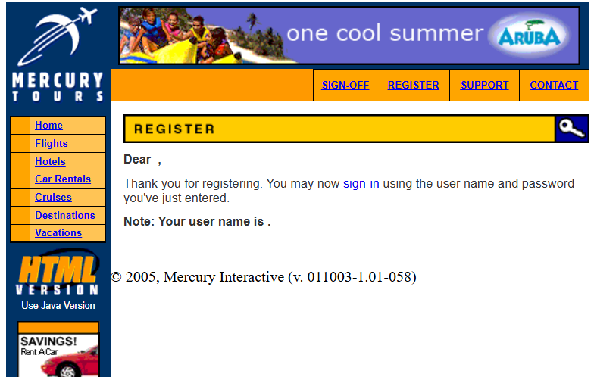
BUG02 | No clear errors for invalid login | Major | Open | 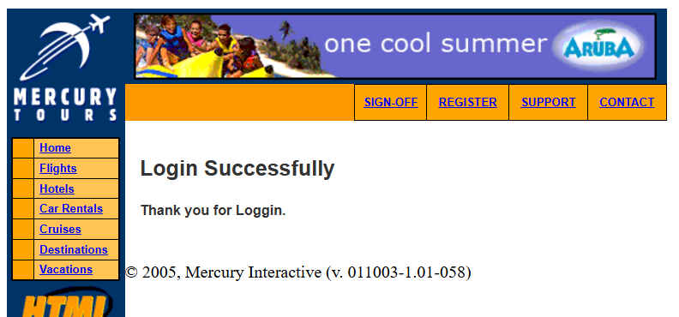
BUG03 | Flight book accepts invalid dates | Medium | Open | 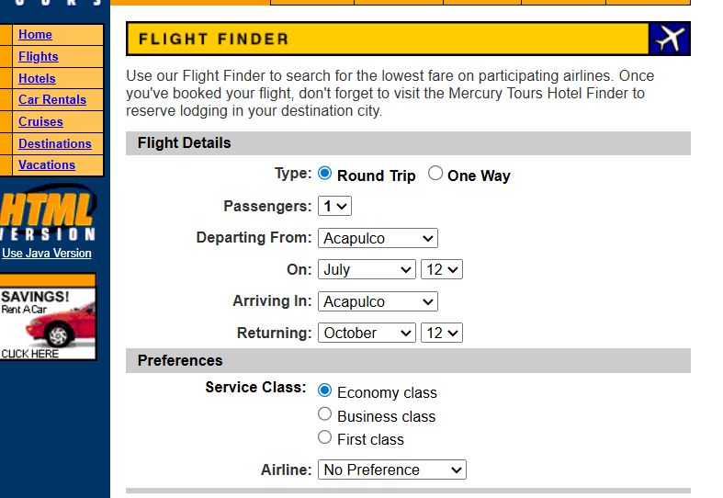
BUG04 | No change in the fields for type selection | Medium | Open | 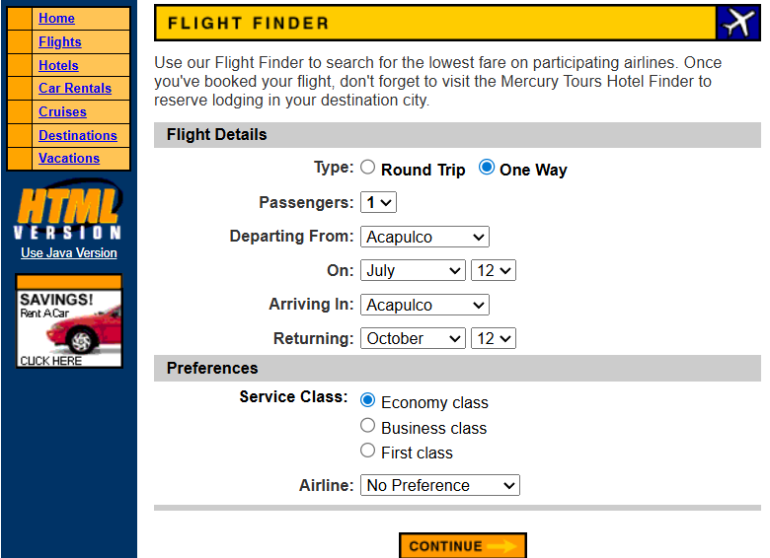
BUG05 | Mandatory fields not highlighted during registration |  |  | 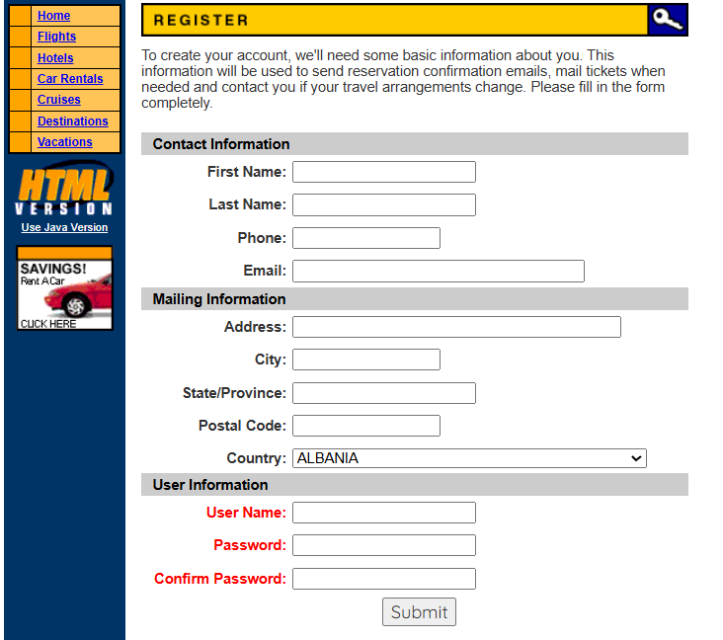
  Major
  Open
BUG06 | No validation message when flight search submitted without date | Major | Open

7. TEST SUMMARY REPORT

Testing Duration: 4 Days
Application Tested: Guru99 New Tours – Flight Booking Application
Application URL: https://demo.guru99.com/test/newtours/
Testing Type: Manual Testing (Functional, UI, Validation)
Environment: Chrome, Edge
Metric | Count
Total Test Scenarios | 14
Total Test Cases | 14
RTM Covered | 12
Test Cases Passed | 8
Test Cases Failed | 6
Blocked | 0

Defect Statistics
- Total Defects: 6
- Major: 3
- Medium: 2
- Minor: 1
- Open: 6
- Closed: 0

Summary Description
Manual testing was conducted on the Guru99 New Tours Flight Booking Demo Application to validate core functionalities such as homepage loading, user registration, login, flight search, booking flow, logout functionality, and UI behavior. The testing covered 12 mapped requirements (RTM) and all planned test cases were executed successfully within the defined testing window.
Most basic functionalities such as homepage accessibility, valid login, navigation, UI consistency, and logout redirection worked as expected. However, several validation-related issues were identified during execution, particularly in the registration, login, and flight search modules.
A total of six defects were logged during the testing cycle. Among them, three major defects directly impact core functionality, including weak validation for registration fields, unclear error messages during invalid login attempts, and acceptance of incomplete flight search inputs. Two medium defects were related to journey type selection behavior and session handling after logout. One minor defect was related to usability and missing user feedback messages.
All identified defects are currently in an open state and require fixes before the application can be considered stable for production-like usage.

Observations
- Mandatory field validation is weak in the registration module.
- Login error handling does not provide clear or user-friendly messages.
- Flight journey type selection (One-way / Round-trip) does not dynamically update fields.
- Some navigation and session behaviors do not follow expected standards.
- UI is generally stable but lacks proper feedback messages in certain flows.

Conclusion
The Guru99 New Tours application is functionally suitable for learning and demonstration purposes, but the presence of multiple validation and usability issues reduces its reliability for real-world usage. Strengthening input validations, improving error messaging, and enhancing session handling will significantly improve user experience and application robustness.
Once the identified defects are resolved and retested, the application will be more stable and aligned with standard flight booking system expectations.

